Closed Surface

Definition
# Source: AI Source: Provided by: [Data Path: Persons Table -> ID Column: 1, Name_En Column: Motasem Essam] -> From: [ChatGPT] on [7/20/2026]
A closed surface is a surface that forms a complete boundary around a three-dimensional region, separating the inside of the region from the outside.
A closed surface has no boundary edges or open ends.
Examples include:
- The surface of a sphere
- The complete surface of a cube
- The complete surface of a cylinder, including both circular bases
- The complete surface of a cone, including its circular base
In mathematical terms, a closed surface is a surface that is self-contained and has no boundary.
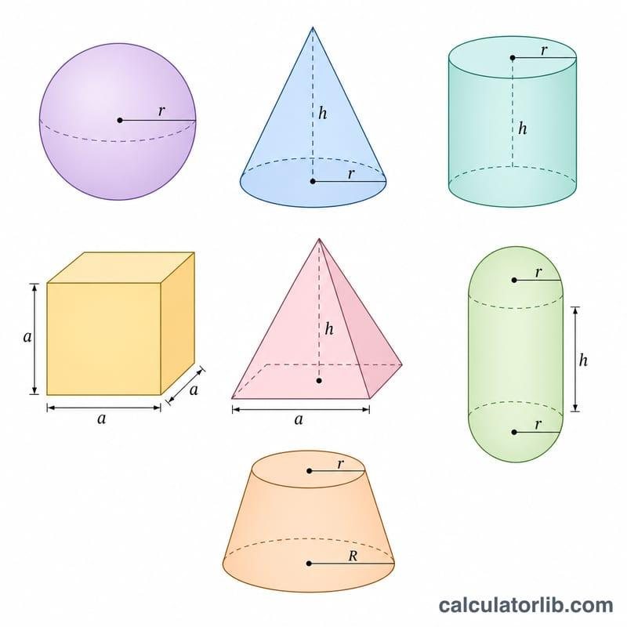
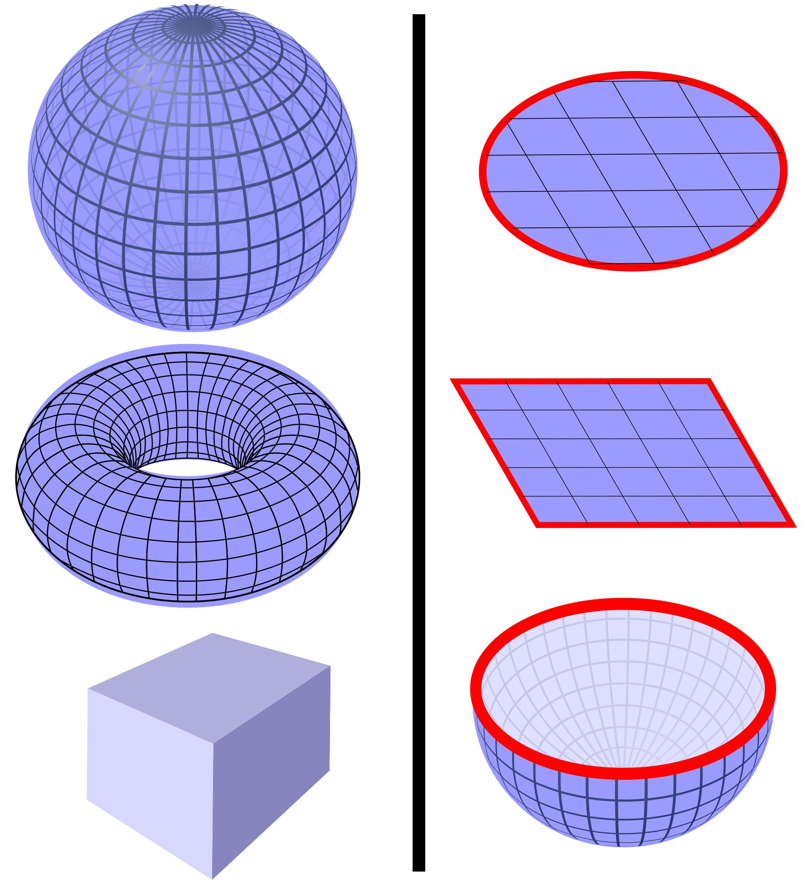
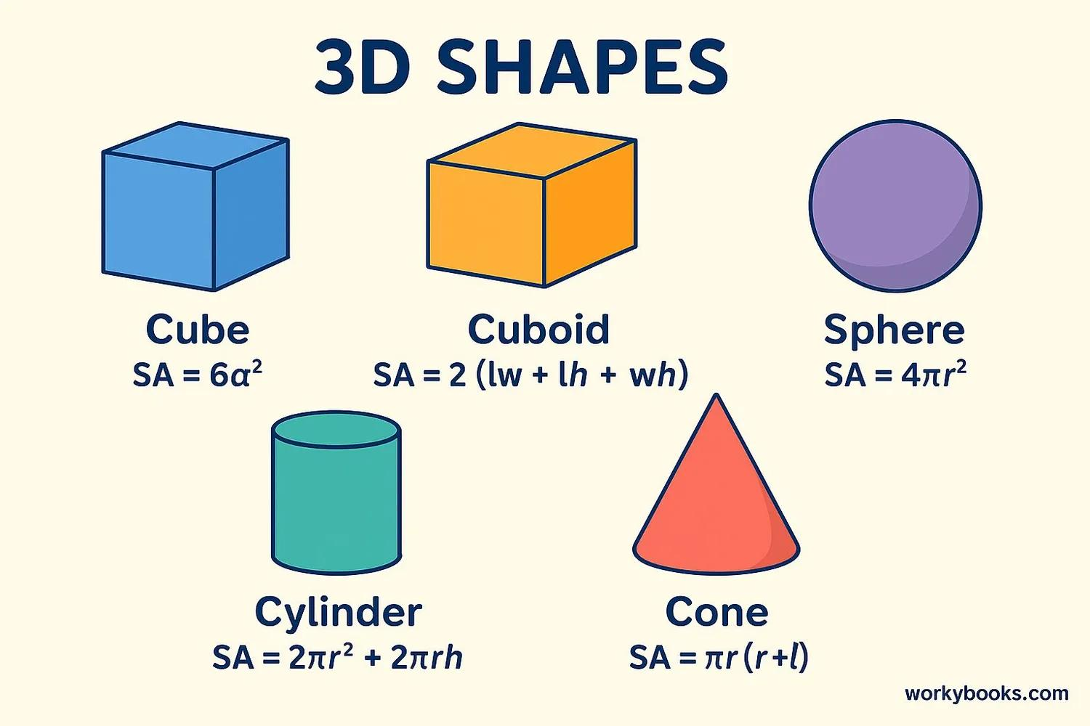
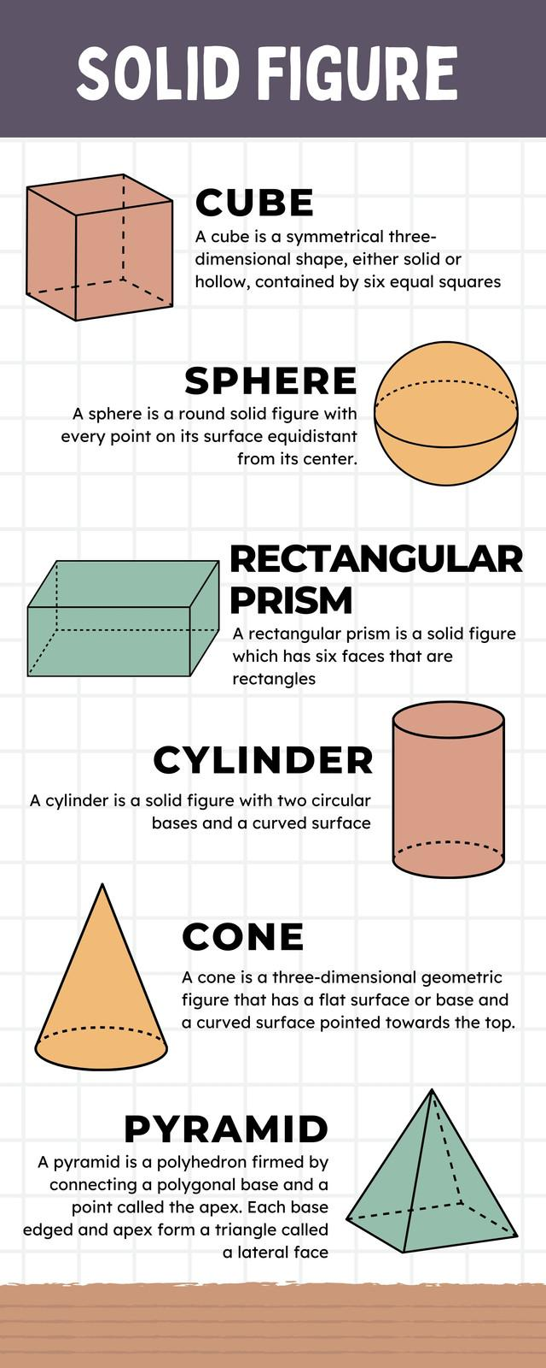
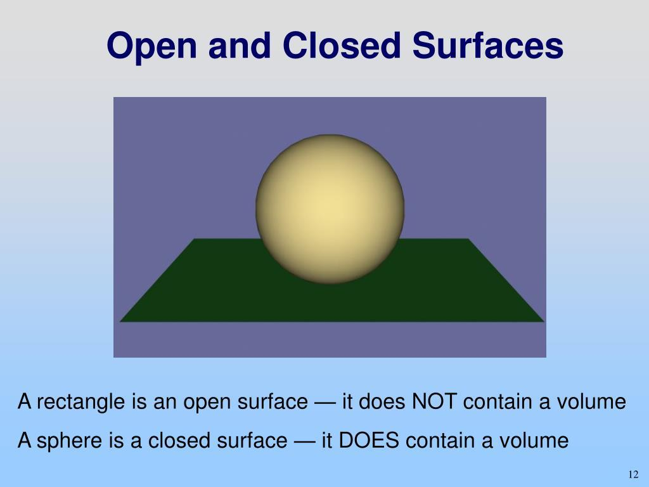

Purpose
# Source: AI Source: Provided by: [Data Path: Persons Table -> ID Column: 1, Name_En Column: Motasem Essam] -> From: [ChatGPT] on [7/20/2026]
Closed surfaces are used to:
- Define the complete boundary of a three-dimensional region.
- Separate an interior from an exterior.
- Calculate total surface area.
- Define enclosed volumes.
- Study three-dimensional geometric objects.
- Provide geometric models for physical containers and enclosures.

Fundamental Characteristics

1. No Boundary
# Source: AI Source: Provided by: [Data Path: Persons Table -> ID Column: 1, Name_En Column: Motasem Essam] -> From: [ChatGPT] on [7/20/2026]
The most important characteristic of a closed surface is that it has no boundary.
For example, the surface of a sphere has no edge where the surface simply stops.
$$\boxed{∂S=∅}$$
where $∂S$represents the boundary of the surface.

2. Encloses a Region
# Source: AI Source: Provided by: [Data Path: Persons Table -> ID Column: 1, Name_En Column: Motasem Essam] -> From: [ChatGPT] on [7/20/2026]
A closed surface completely surrounds a three-dimensional region.
For example:
$$\boxed{\text{Sphere surface}→\text{encloses a volume}}$$
The surface itself has area, while the enclosed region has volume.

3. Separates Inside and Outside
# Source: AI Source: Provided by: [Data Path: Persons Table -> ID Column: 1, Name_En Column: Motasem Essam] -> From: [ChatGPT] on [7/20/2026]
A closed surface separates space into:
- An interior
- An exterior
For example, the surface of a ball separates the inside of the ball from the space outside it.

4. Complete Surface
# Source: AI Source: Provided by: [Data Path: Persons Table -> ID Column: 1, Name_En Column: Motasem Essam] -> From: [ChatGPT] on [7/20/2026]
A closed surface includes all portions necessary to form a complete boundary.
For example, a cylinder without its circular bases has an open lateral surface:
$$\text{Curved surface only}→\text{Open}$$
Adding both bases gives:
$$\text{Curved surface + 2 bases}→\text{Closed}$$
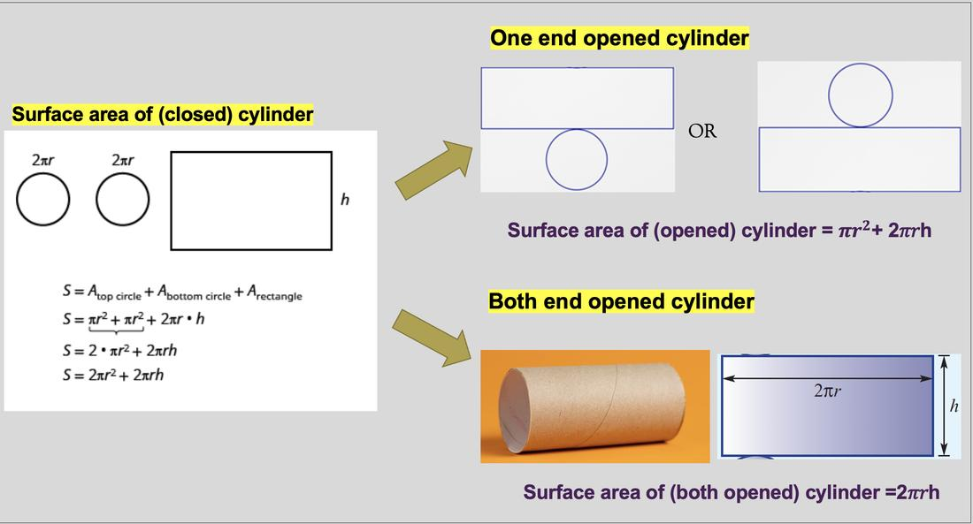
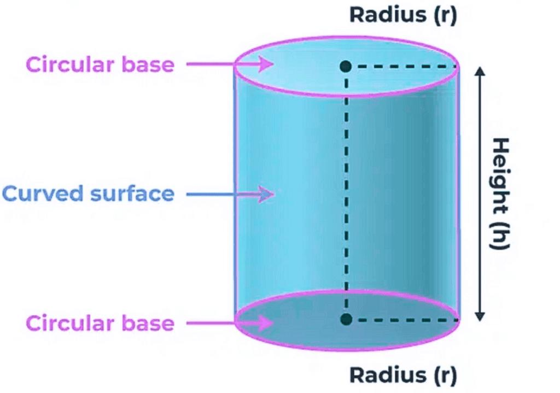
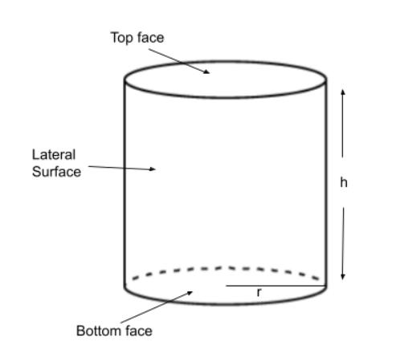
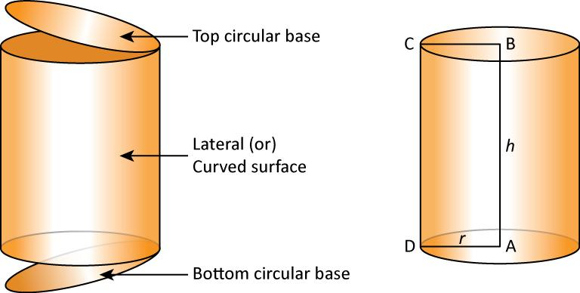
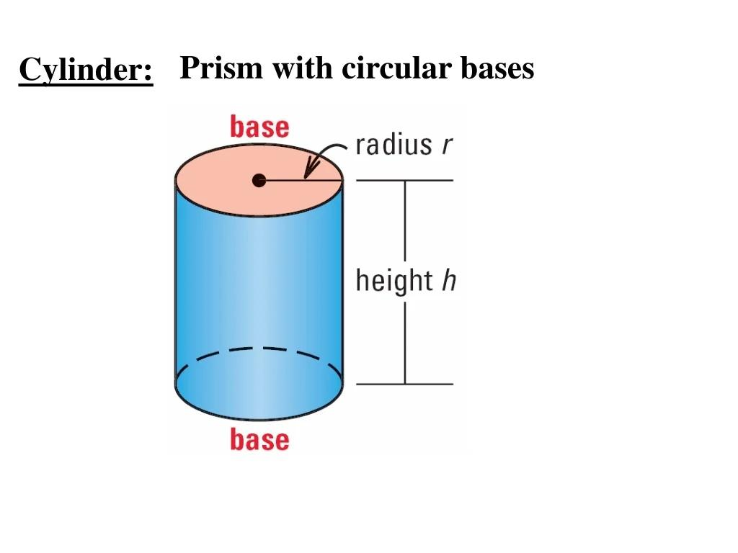

Examples of Closed Surfaces

1. Spherical Surface
# Source: AI Source: Provided by: [Data Path: Persons Table -> ID Column: 1, Name_En Column: Motasem Essam] -> From: [ChatGPT] on [7/20/2026]
The surface of a sphere is a classic example of a closed surface.
It completely surrounds its interior.
For a sphere of radius $r$:
$$SA=4πr^{2}$$
and the enclosed volume is:
$$V=\frac{4}{3}πr^{3}$$
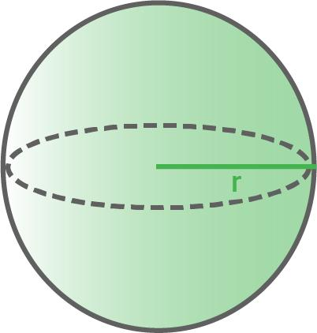
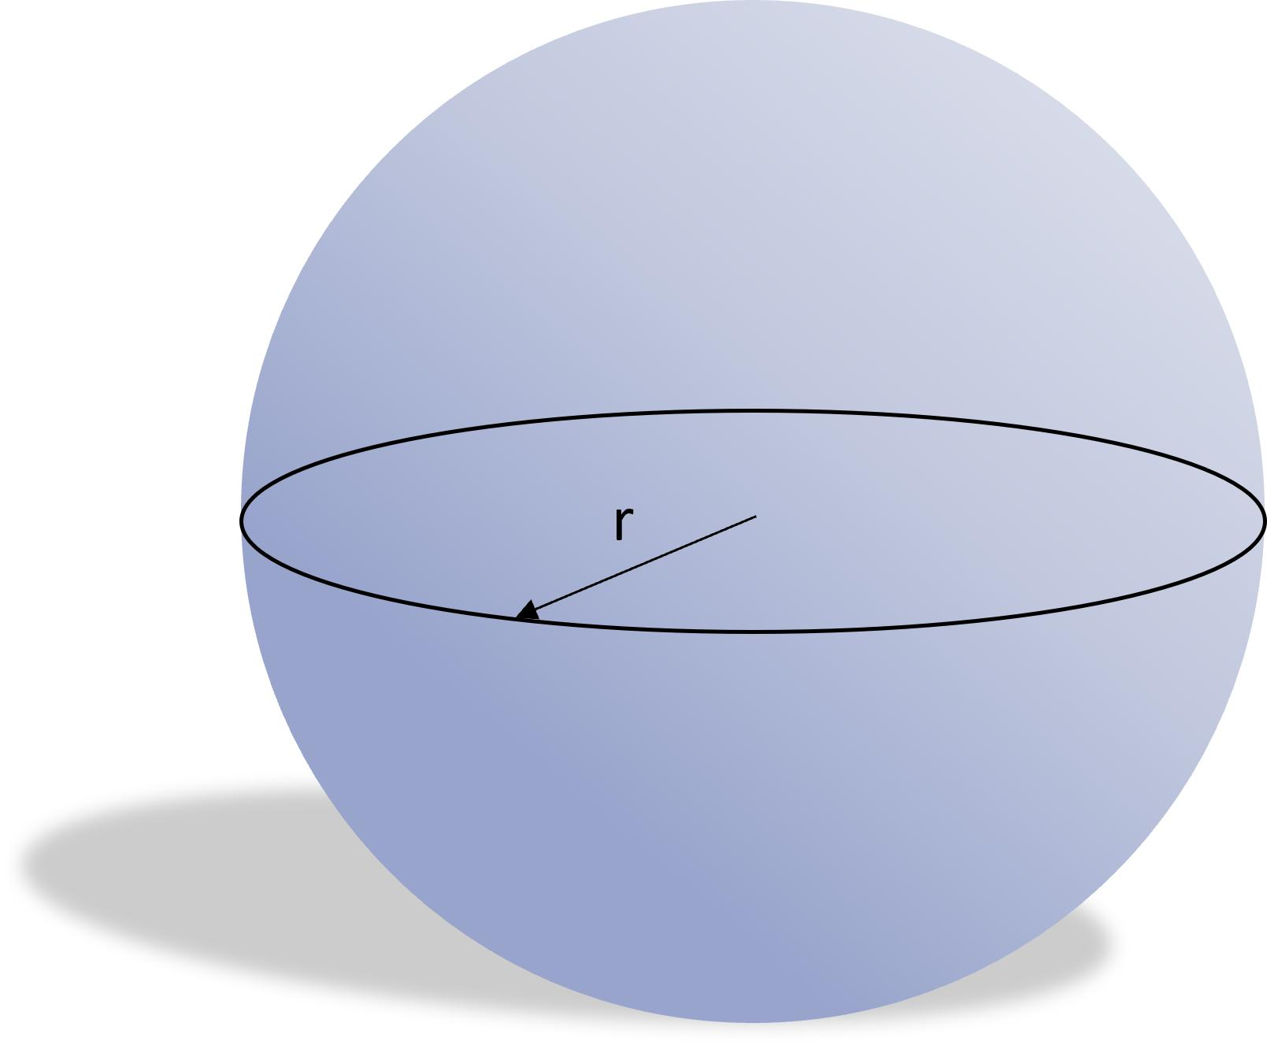
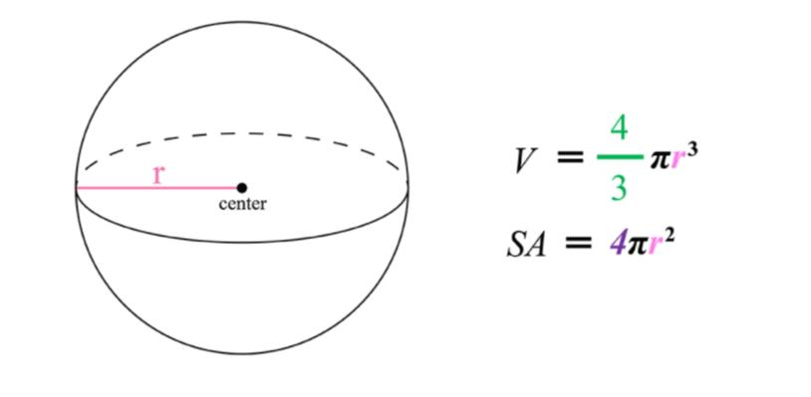
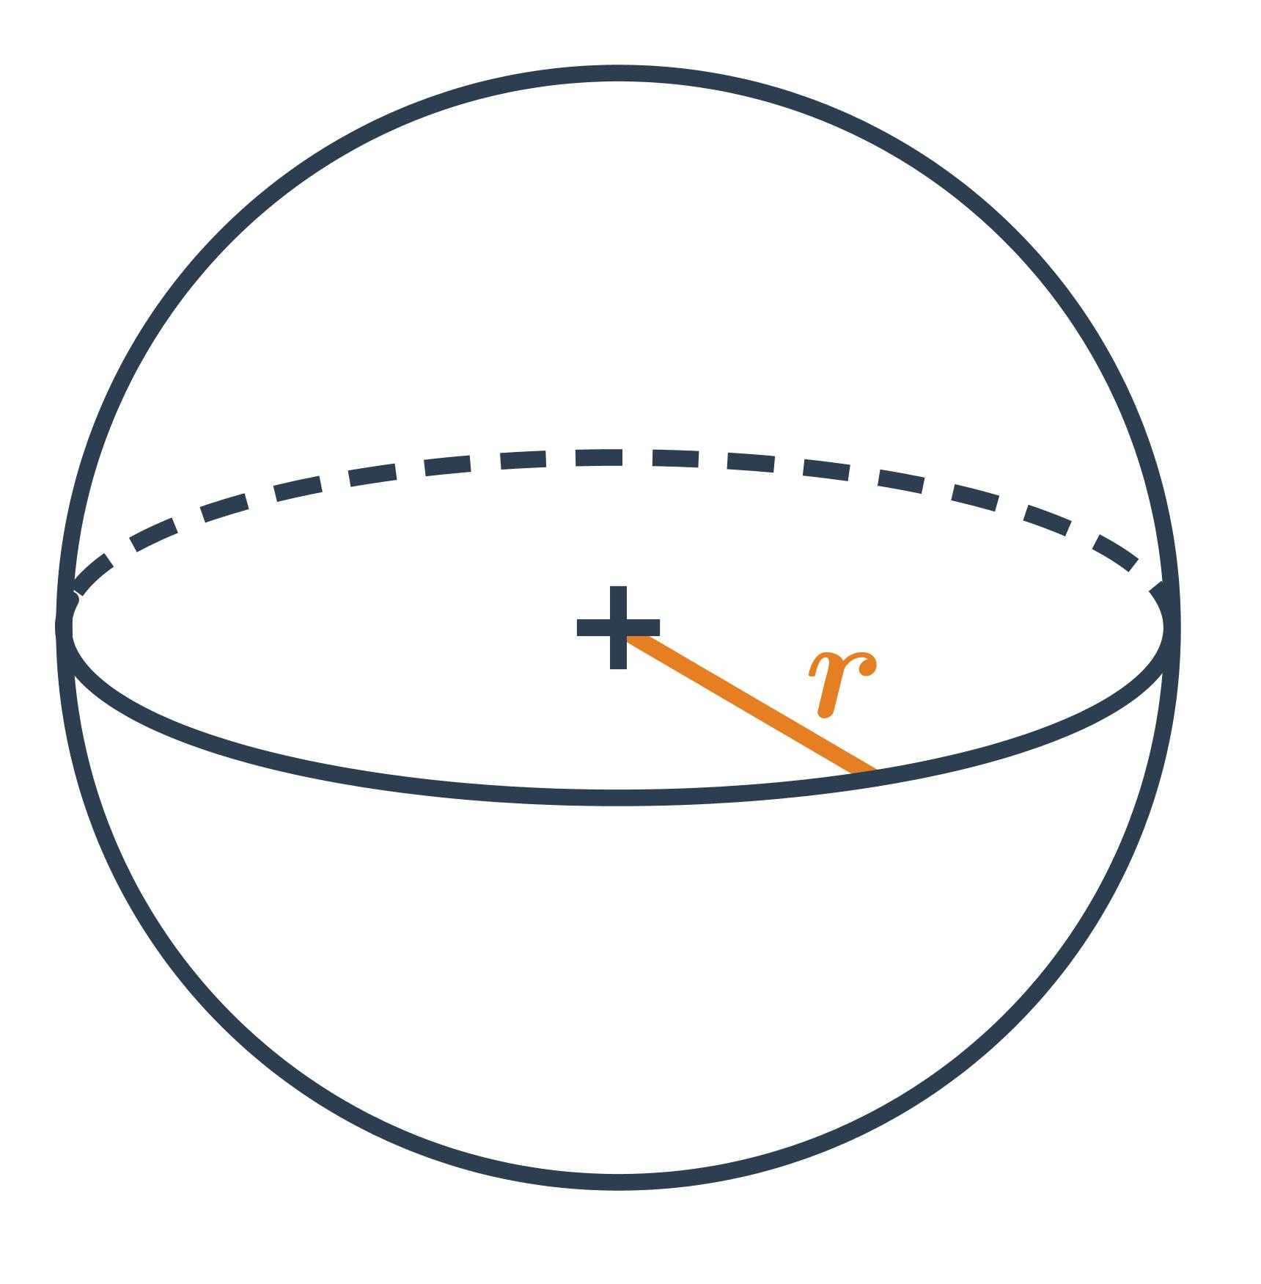

2. Surface of a Cube
# Source: AI Source: Provided by: [Data Path: Persons Table -> ID Column: 1, Name_En Column: Motasem Essam] -> From: [ChatGPT] on [7/20/2026]
The six square faces of a cube together form a closed surface.
If the side length is $s$:
$$SA=6s^{2}$$
The six faces completely enclose the cube's interior.

3. Closed Cylindrical Surface
# Source: AI Source: Provided by: [Data Path: Persons Table -> ID Column: 1, Name_En Column: Motasem Essam] -> From: [ChatGPT] on [7/20/2026]
A complete cylinder consists of:
- One curved lateral surface
- Two circular plane surfaces
Therefore:
$$SA=2πrh+2πr^{2}$$
The complete combination forms a closed surface.

4. Closed Conical Surface
# Source: AI Source: Provided by: [Data Path: Persons Table -> ID Column: 1, Name_En Column: Motasem Essam] -> From: [ChatGPT] on [7/20/2026]
A complete cone consists of:
- One curved lateral surface
- One circular base
Therefore:
$$SA=πrl+πr^{2}$$
where $l$is the slant height.
Together, these surfaces completely enclose the cone's interior.

5. Polyhedra
# Source: AI Source: Provided by: [Data Path: Persons Table -> ID Column: 1, Name_En Column: Motasem Essam] -> From: [ChatGPT] on [7/20/2026]
The complete boundary of a polyhedron is a closed surface.
Examples include:
- Cube
- Rectangular prism
- Tetrahedron
- Octahedron
- Dodecahedron
- Icosahedron
Each face is a plane surface, but together the faces form a closed surface.
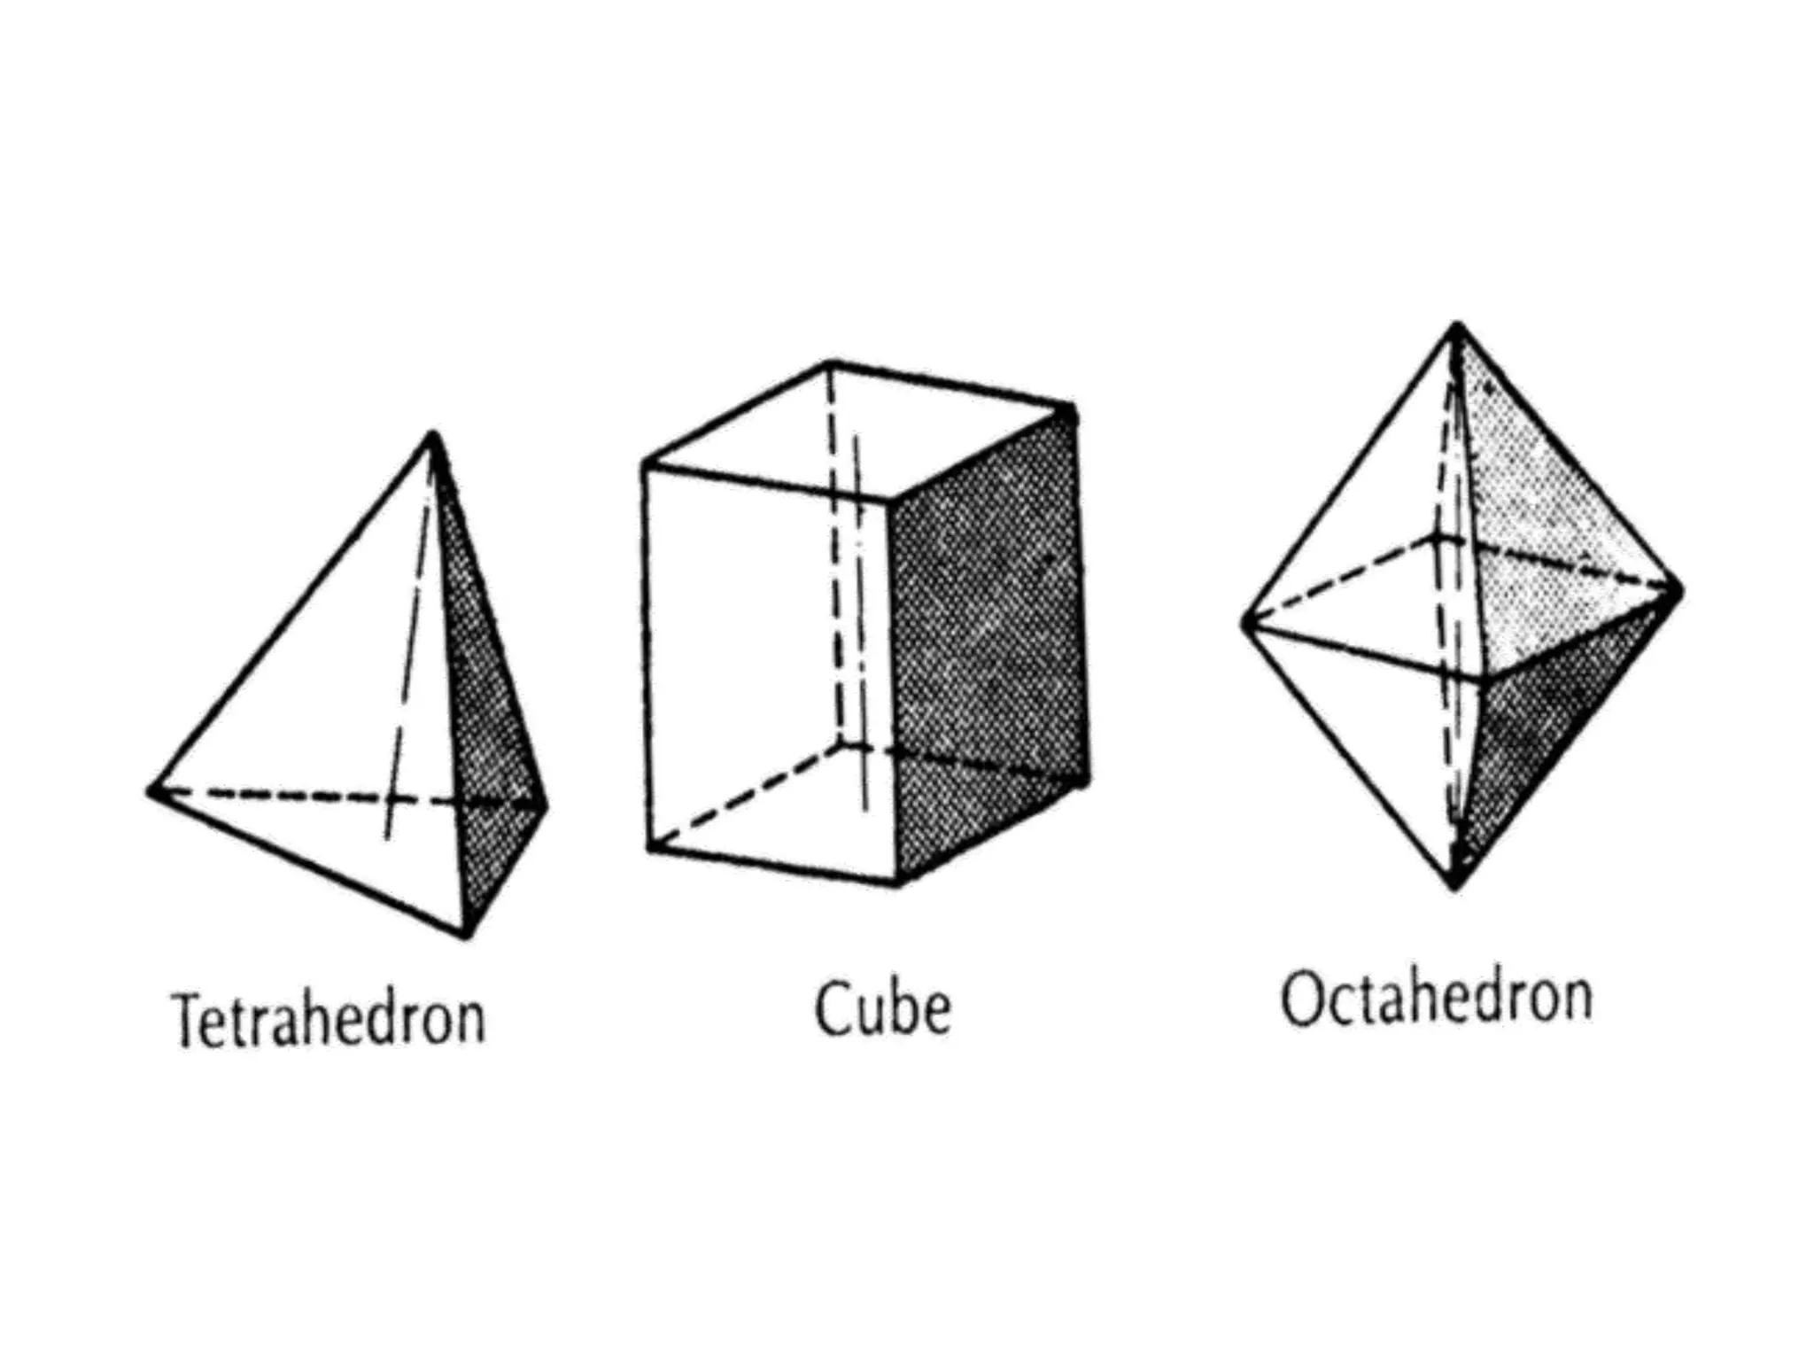
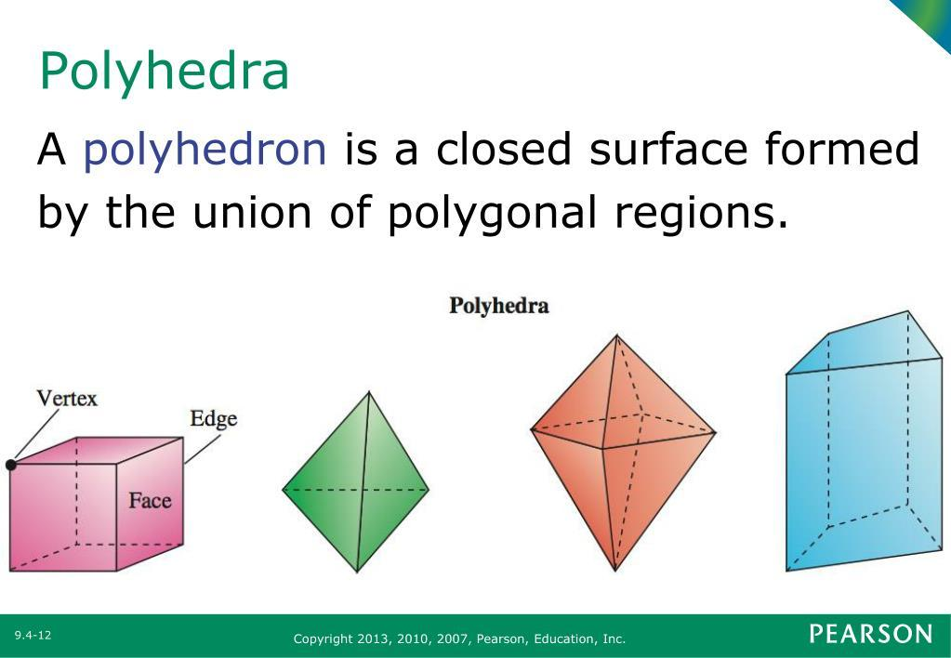
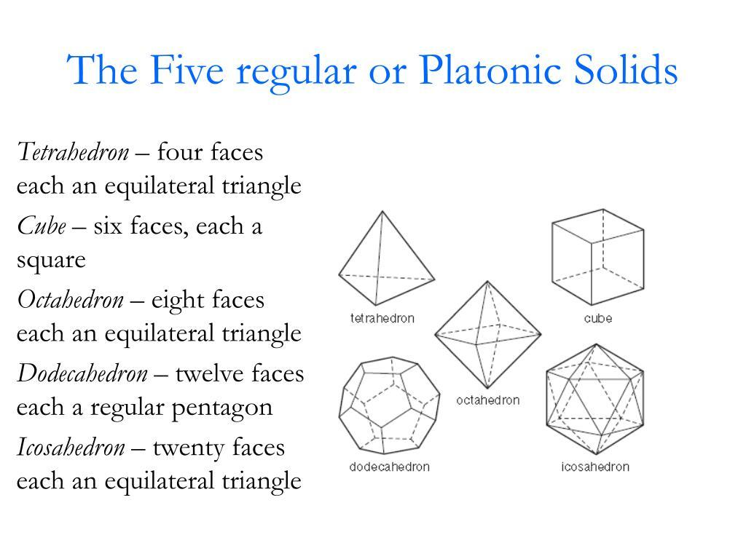
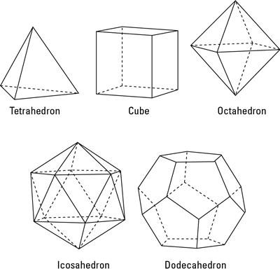
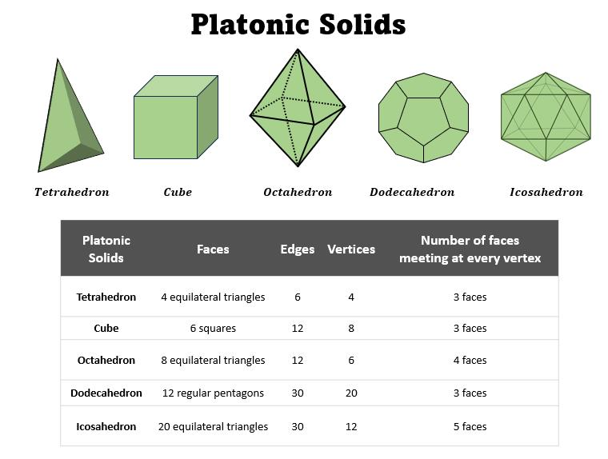

Closed Surface vs Open Surface
# Source: AI Source: Provided by: [Data Path: Persons Table -> ID Column: 1, Name_En Column: Motasem Essam] -> From: [ChatGPT] on [7/20/2026]
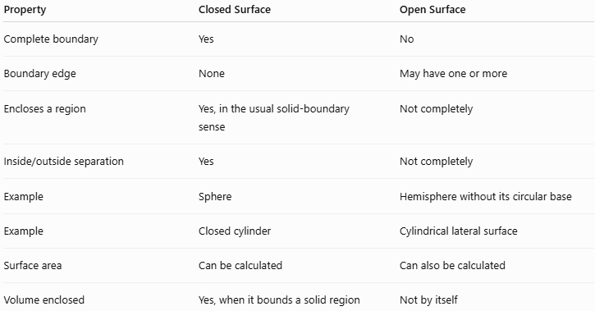
Property | Closed Surface | Open Surface
Complete boundary | Yes | No
Boundary edge | None | May have one or more
Encloses a region | Yes, in the usual solid-boundary sense | Not completely
Inside/outside separation | Yes | Not completely
Example | Sphere | Hemisphere without its circular base
Example | Closed cylinder | Cylindrical lateral surface
Surface area | Can be calculated | Can also be calculated
Volume enclosed | Yes, when it bounds a solid region | Not by itself
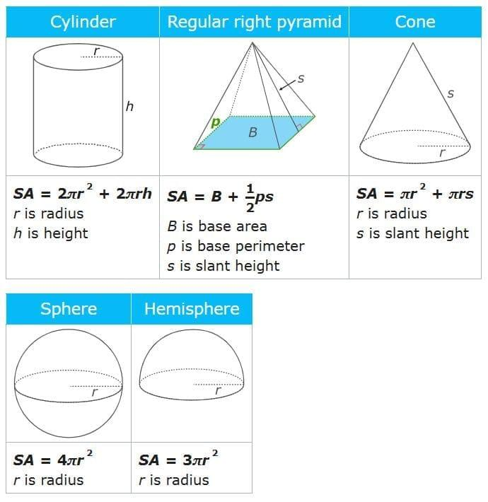

Closed Surface vs Solid
# Source: AI Source: Provided by: [Data Path: Persons Table -> ID Column: 1, Name_En Column: Motasem Essam] -> From: [ChatGPT] on [7/20/2026]
It is important not to confuse a closed surface with a solid.
Closed Surface
The surface is only the boundary:
$$\boxed{\text{Surface}→\text{Area}}$$
Solid
The solid includes the interior region:
$$\boxed{\text{Solid}→\text{Volume}}$$
For a sphere:
$$SA=4πr^{2}$$
while:
$$V=\frac{4}{3}πr^{3}$$
Thus:
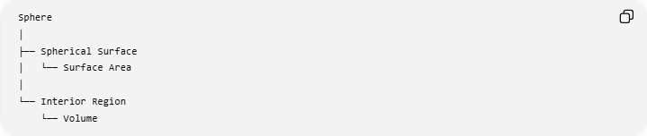
Sphere
│
├── Spherical Surface
│ └── Surface Area
│
└── Interior Region
└── Volume

Mathematical Representation
# Source: AI Source: Provided by: [Data Path: Persons Table -> ID Column: 1, Name_En Column: Motasem Essam] -> From: [ChatGPT] on [7/20/2026]
A closed surface can be represented as the boundary of a three-dimensional region $V$:
$$S=∂V$$
For example, a sphere centered at the origin with radius $r$can be represented by:
$$x^{2}+y^{2}+z^{2}=r^{2}$$
This equation describes the surface of the sphere, not the solid interior.
The solid ball is described by:
$$x^{2}+y^{2}+z^{2}≤r^{2}$$
Therefore:
$$\boxed{x^{2}+y^{2}+z^{2}=r^{2}}$$
represents the spherical surface, while:
$$\boxed{x^{2}+y^{2}+z^{2}≤r^{2}}$$
represents the enclosed solid region.

Example
# Source: AI Source: Provided by: [Data Path: Persons Table -> ID Column: 1, Name_En Column: Motasem Essam] -> From: [ChatGPT] on [7/20/2026]
Consider a cylinder with:
$$r=3\text{ cm}$$
and:
$$h=10\text{ cm}$$
Its complete surface consists of the curved surface and two circular bases.
Curved surface area
$$CSA=2πrh \\ CSA=2π\left(3\right)\left(10\right)=60π$$
Area of two bases
$$A_{\text{bases}}=2πr^{2} \\ A_{\text{bases}}=2π{\left(3\right)}^{2}=18π$$
Total surface area
$$SA=60π+18π \\ \boxed{SA=78π{\text{ cm}}^{2}}$$
The complete surface is closed because the two circular bases close the two ends of the cylindrical lateral surface.

Special Case: Hemisphere
# Source: AI Source: Provided by: [Data Path: Persons Table -> ID Column: 1, Name_En Column: Motasem Essam] -> From: [ChatGPT] on [7/20/2026]
A hemisphere demonstrates why the word "complete" is important.
The curved surface of a hemisphere alone is open because it has a circular boundary.
If its circular base is included:
$$\text{Curved hemispherical surface + circular base}$$
then the resulting surface is closed.
For radius $r$:
Curved surface area:
$$CSA=2πr^{2}$$
Total surface area of a closed hemisphere:
$$TSA=3πr^{2}$$

Properties of Closed Surfaces
# Source: AI Source: Provided by: [Data Path: Persons Table -> ID Column: 1, Name_En Column: Motasem Essam] -> From: [ChatGPT] on [7/20/2026]
A closed surface generally:
- Has no boundary.
- Forms a complete enclosure.
- Separates an interior from an exterior.
- Can serve as the boundary of a solid region.
- Has a measurable surface area.
- May consist of plane surfaces, curved surfaces, or both.

Real-World Applications
# Source: AI Source: Provided by: [Data Path: Persons Table -> ID Column: 1, Name_En Column: Motasem Essam] -> From: [ChatGPT] on [7/20/2026]
Closed surfaces are used to model:
- Containers
- Tanks
- Bottles
- Balls
- Buildings
- Enclosures
- Pressure vessels
- Storage tanks
- Packaging
- Mechanical components
- Architectural structures
- 3D computer models
For example, the surface of a closed water tank forms the boundary of the volume that can contain water.

Relationship with Related Concepts
# Source: AI Source: Provided by: [Data Path: Persons Table -> ID Column: 1, Name_En Column: Motasem Essam] -> From: [ChatGPT] on [7/20/2026]
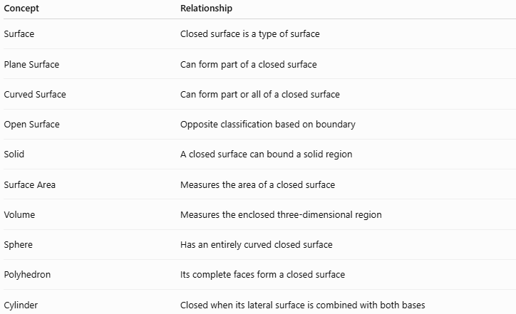
Concept | Relationship
Surface | Closed surface is a type of surface
Plane Surface | Can form part of a closed surface
Curved Surface | Can form part or all of a closed surface
Open Surface | Opposite classification based on boundary
Solid | A closed surface can bound a solid region
Surface Area | Measures the area of a closed surface
Volume | Measures the enclosed three-dimensional region
Sphere | Has an entirely curved closed surface
Polyhedron | Its complete faces form a closed surface
Cylinder | Closed when its lateral surface is combined with both bases

Key Points
# Source: AI Source: Provided by: [Data Path: Persons Table -> ID Column: 1, Name_En Column: Motasem Essam] -> From: [ChatGPT] on [7/20/2026]
- A closed surface is a complete surface with no boundary.
- It forms a complete boundary around a three-dimensional region.
- It separates an interior from an exterior.
- A sphere is a classic example.
- A complete cube, cylinder, or cone also has a closed surface.
- A surface can be both curved and closed.
- A surface can be plane and part of a closed surface.
- Open/closed describes the boundary condition, while plane/curved describes the geometric form.
- A closed surface can be represented as the boundary of a three-dimensional region:
$$S=∂V$$

Conclusion
# Source: AI Source: Provided by: [Data Path: Persons Table -> ID Column: 1, Name_En Column: Motasem Essam] -> From: [ChatGPT] on [7/20/2026]
A closed surface is a complete, boundary-free surface that encloses a three-dimensional region. It may consist entirely of curved surfaces, entirely of plane surfaces, or a combination of both. The sphere, cube, cylinder, and cone provide important examples. For your taxonomy, Open Surface and Closed Surface should be classified separately from Plane Surface and Curved Surface, because they describe different properties of a surface.

